1.

EdWisor: If the variance of a variable/column is 0 then what does it mean? Can we use that variable for our analysis?

Uday: If variance is 0, this means the data which is taken for analysis is identical. For ex: data is runs scored by Kohli in last 10 matches. So if the variance of this data is 0, then runs scored by kohli is same in all the 10 matches.

I don’t think this data is suitable for analysis, I can say that for the example I have given , I can just say that Kohli is consistent but other than this it cant be used for any analysis.

2.

EdWisor: Calculate mean, median, mode, variance and standard deviation for column A

Uday: 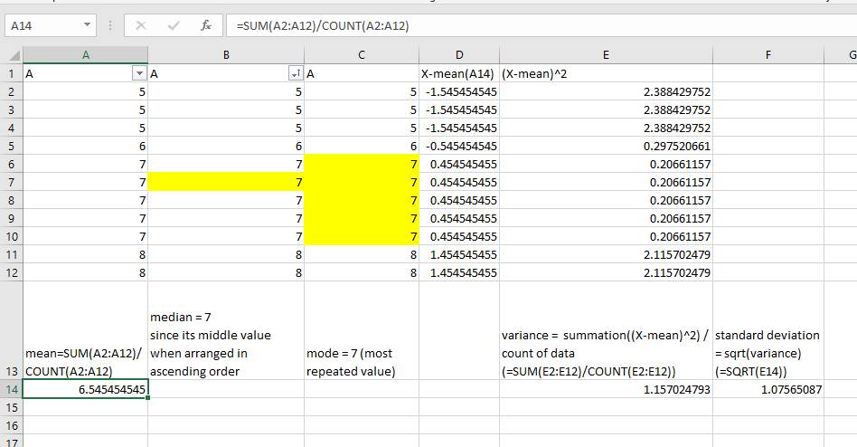

EdWisor:

In a group of 12 scores, the largest score is increased by 36 points. What effect will this have on the mean of the scores?

Uday: The mean will increase by 3

Mean_old = summation ( 12 elements) / 12

Mean_new= summation (12 elements + 36)/12

= [summation (12 elements) /12 ] + 36/12

= Mean_old + 3

EdWisor:

Explain the difference between Data (Singular) and Data (Plural) with examples?

Uday: In the above excel screenshot consider column A, any element (A1 to A12) in the column is called data singular.

The collective data or any number (>1) of sample data is called data plural.

Ex : A3 is singular data

A6 to A12 is Plural data.

EdWisor:

How the inferential statistics helps to make decisions out of it?

Uday: Inferential statistics refer to sample of data and not complete data. According to central tendency if we plot the graph of all the sample of data , it follows uniform distribution. So, Inferential statistics helps us understand the whole data just by considering sample data. Ex: to check whether rice is cooked , we need not check whole cooker. By just considering pinch of rice on top of the cooker is enough to conclude whether rice is cooked or not.